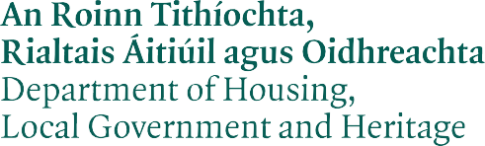

APPLICATION FOR CONSENT
Section 14 of the National Monuments Act 1930 (as amended).
Applicant
Name: Address:

Telephone:
Email:
Director of Services/ Authorised Officer:

National Monument

RMP Number: Name of Monument:
Location
(Townland/County):

ITM Reference: **

* Record of Monuments and Places/Register of Historic Monuments Ref. No. (for example, CL001-001---).
** The Archaeological Survey of Ireland uses mapping provided by OSI, this utilises the Irish Transverse Mercator (ITM) co-ordinate system. This replaces the former Irish Grid referenced mapping. If possible, please supply ITM co-ordinates. Users may derive the ITM co-ordinates from the mapping component of the National Monuments Service website: www.archaeology.ie

Owner Details (Complete as Appropriate)
Local Authority
Name:
Address:
Telephone:
Email:
Director of Services/
Authorised Officer:
Private Owner
Name:
Address:
Telephone:
Email:
Works
Purpose of Proposed
Works:

Description of Proposed Works: Continue on a separate sheet if required

Items to be Included
All applications can be submitted electronically to:
nationalmonuments@housing.gov.ie
Please use S14 Ministerial Consent Application in your email subject line and ensure the following items are included with your application:
- OS map, at either of the following scales, marking the location of the site:
  - Rural 1:5000/1:10000
  - Urban 1:1000
- Name and contact details of archaeologist/architect/engineer preparing documents.
- Method Statement (if archaeological excavation required).
- Letter from Local Authority (if applying on behalf of a Local Authority) or written confirmation of owner’s permission.
- Any reference numbers associated with the project. For example, the heritage project reference number assigned by the Department of Housing, Local Government and Heritage and any planning application reference number (where available) assigned by the relevant planning authority.

Important Note: It should not be assumed that this Ministerial Consent form has been received by the National Monuments Service until you have received confirmation in writing to that effect.

Signature:
Date:

